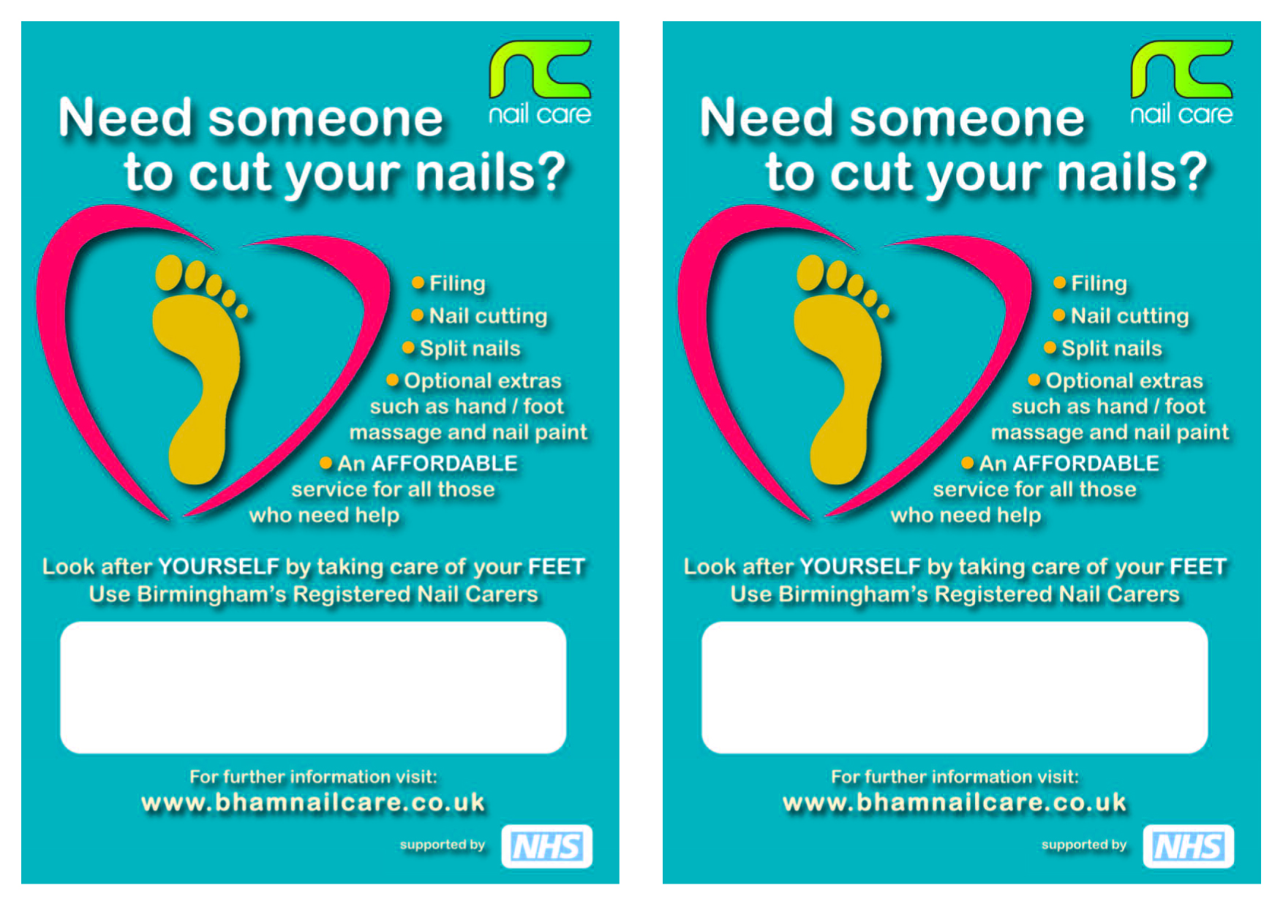

Type your text in here using this text box.

Type your text in here using this text box.