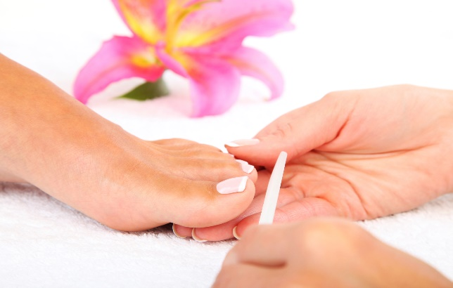
Nail Care Service: HAPPY FEET

Name of Nail Carer: Nena Jeffrey

Telephone Number: 07949014309

Email address: njeffrey@hotmail.co.uk

Location: West Midlands B23

Languages spoken: English

 | Menu services
1 | Initial assessment, nail cut, file to include equipment (toenail clippers and foot file) cuticle stick, 1 medium,1 small nail file all with protective equipment case. | £23
2 | Subsequent toenail nail cut, file, hard skin filing. | £14
3 | Foot massage at the same time as 1 or 2 above | £5
4 | Fingernail cut, file and hand massage at the same time as 1 or 2 above | £10
5 | Nail polish fingers or toes at the same time as 1 or 2 above | £4
6 | Nail polish fingers and toes at the same time as 1or 2 above | £7
7 | Replacement equipment  Nail clippers  Large foot file  Cuticle stick, 1 medium and 1 small nail file  Protective equipment case | £7  £3  £3  £3
6 | Additional cost outside of Erdington, New Oscott, Kingstanding, Great Barr, Perry Barr, Boldmere, Wylde Green, Streetly and Sutton Coldfield. | £5
 | Home Visits are available for housebound clients
 | Clients with diabetes will need their low risk status confirmation letter from their GP or Podiatrist before treatment can commence.

